**CSE 307 : INTERNETWORKING ESSENTIALS**

**Bachelors Of Technology**

**In**

**Computer Science & Engineering**

**CONTINUOUS ASSESSMENT - II**

**Submitted By :**

Name – Sana Perween

Reg. Id – 12304577

Roll No. – 31

**Submitted To:**

Mr. Simarjeet Singh Malhi Sir



**LOVELY PROFESSIONAL UNIVERSITY**

**PUNJAB INDIA**

**Project31:** You are hired as a network engineer for **Care Network Solutions**, a mid-sized enterprise with a **5-floor** office building. Each floor is equipped with **10 computers**, and the organization requires a well-structured network to ensure efficient communication and scalability.

**Network Design Requirements:**

1. **Topology Selection:** Design a **ring topology** for the first 2 floors, **star topology** for the next 1 floor, and **mesh topology** for the remaining floors, considering performance and fault tolerance.
2. **IP Addressing Scheme:** The company has decided to use **Class A private IPv4 addresses for the first three floors, Class B private IPv4 addresses for the next two floors, and then Class C public IPv4 addresses for the remaining floors**, following a **classful addressing scheme**. Allocate IP addresses properly for each floor, ensuring uniqueness.
3. **Routing Strategy for Inter-Floor Communication & Connectivity:** Recommend a **routing approach** that is **static** for inter-floor communication.
   * Design how the floors will be connected for **seamless inter-department communication**.
   * Suggest the appropriate **network devices** (e.g., switches, routers, access points) and their placement.
   * If using **dynamic routing**, suggest an appropriate routing protocol (e.g., **RIP, OSPF, or EIGRP**) with justification.
   * If using **static routing**, define the **static routes** for efficient data flow.
   * Specify the number of **default gateways** along with IP addresses.

**Report Writing:**

Write the project report, which includes all the above things along with the labeled **network scenario**, and also mention the innovation done by you in the project.

Then upload the project on **GitHub** as well as check the **engagement level** of the project uploaded on GitHub.

**1.TOPOLOGY SECTION**

1. 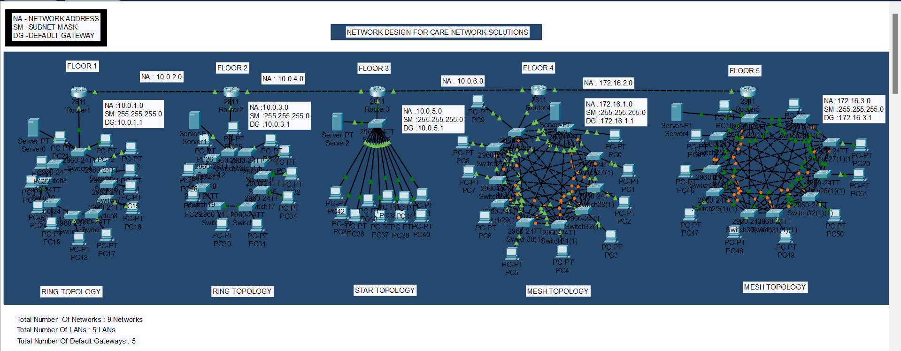a **5-floor** Office Building
2. a **Ring Topology** for the first 2 floors

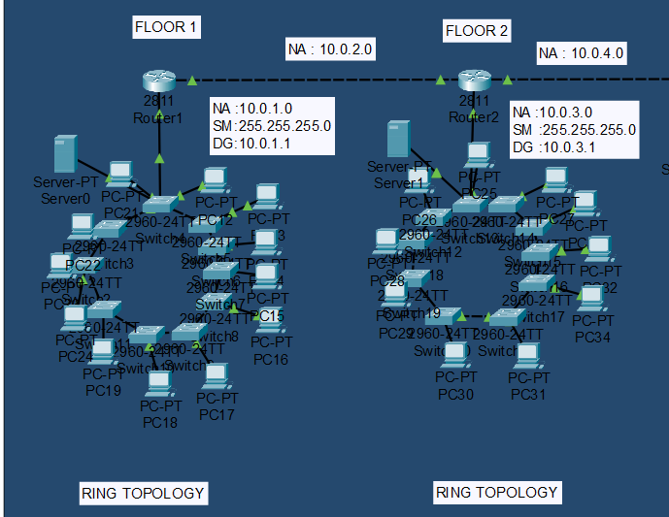

1. **Star Topology** for the next 1 floor

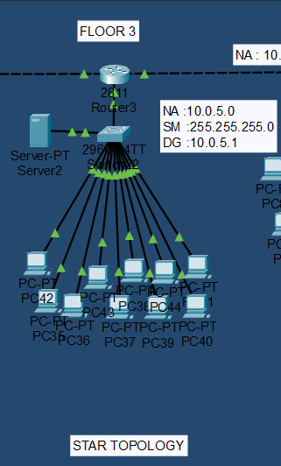

1. **Mesh Topology** for the remaining floors

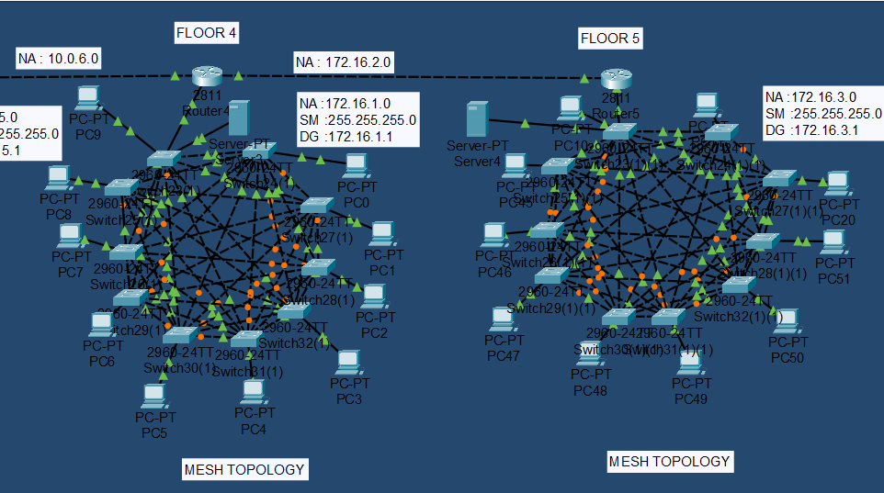

1. **IP ADDRESSING SCHEME:**
2. We use **Class A private IPv4 addresses for the first three floors**

* The Class A private IP address range is 10.0.0.0 to 10.255.255.255. This range is reserved for large networks.

1. **First Floor -Ring Topology**

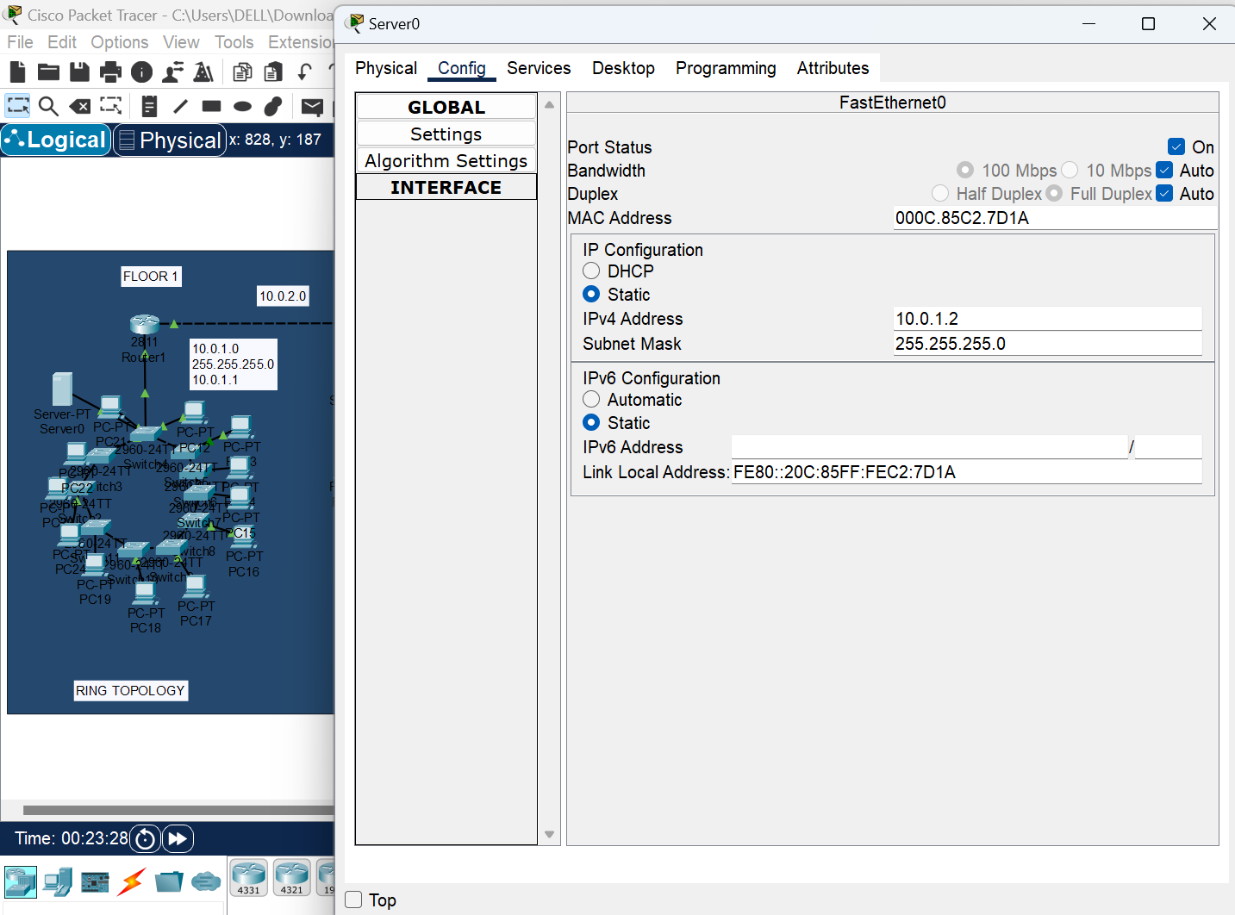

**First Floor End – Device Configuration**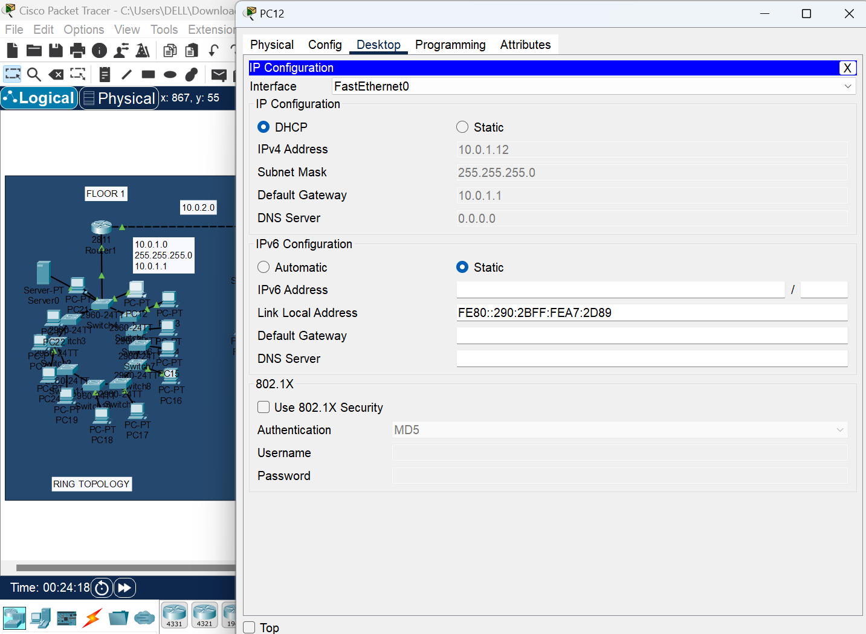

1. **Second floor – Ring Topology**

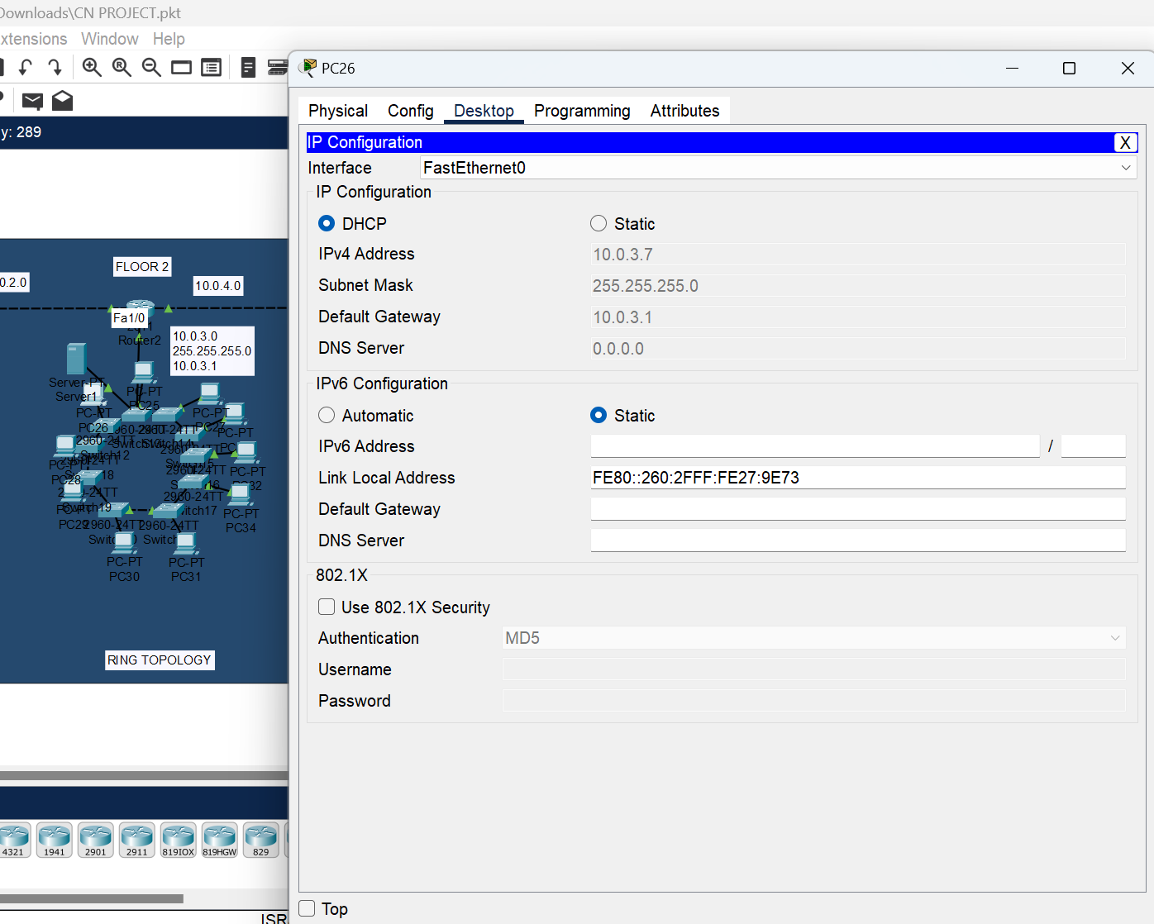

**Second Floor End – Device Configuration**

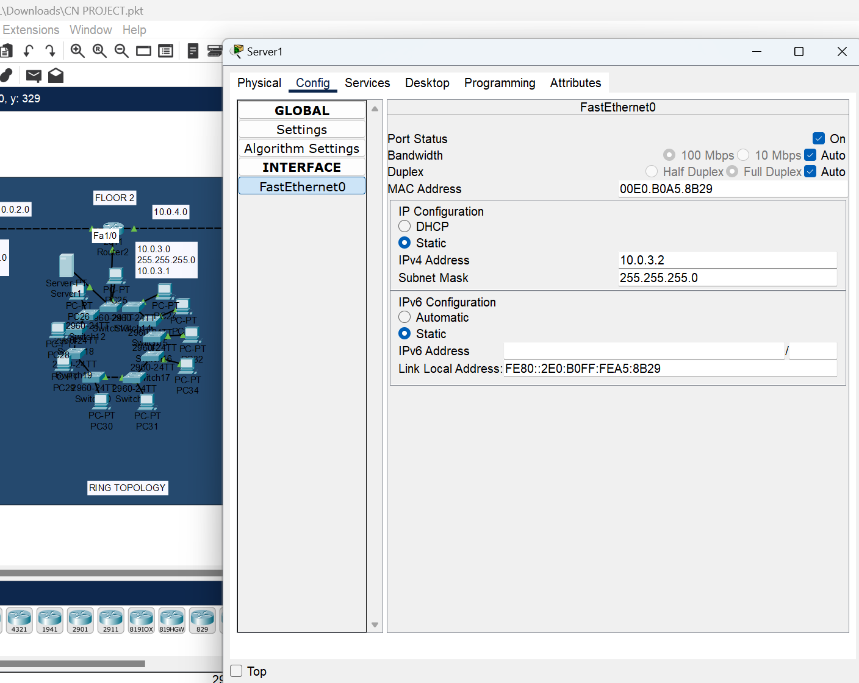

1. **Third Floor - Star Topology**

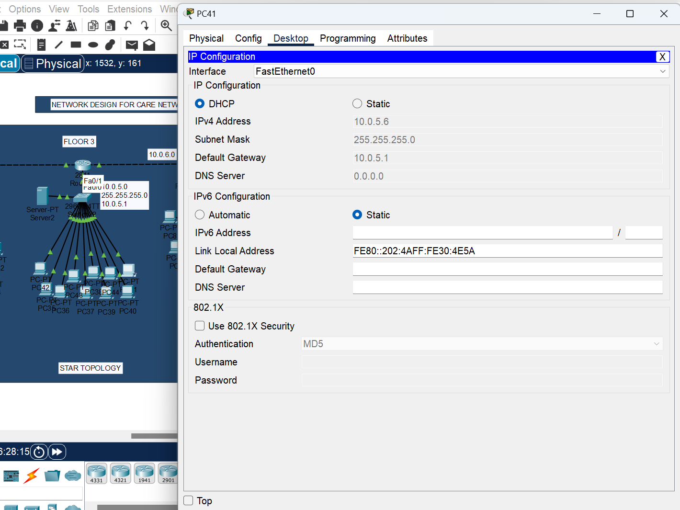

**Third Floor End – Device Configuration**

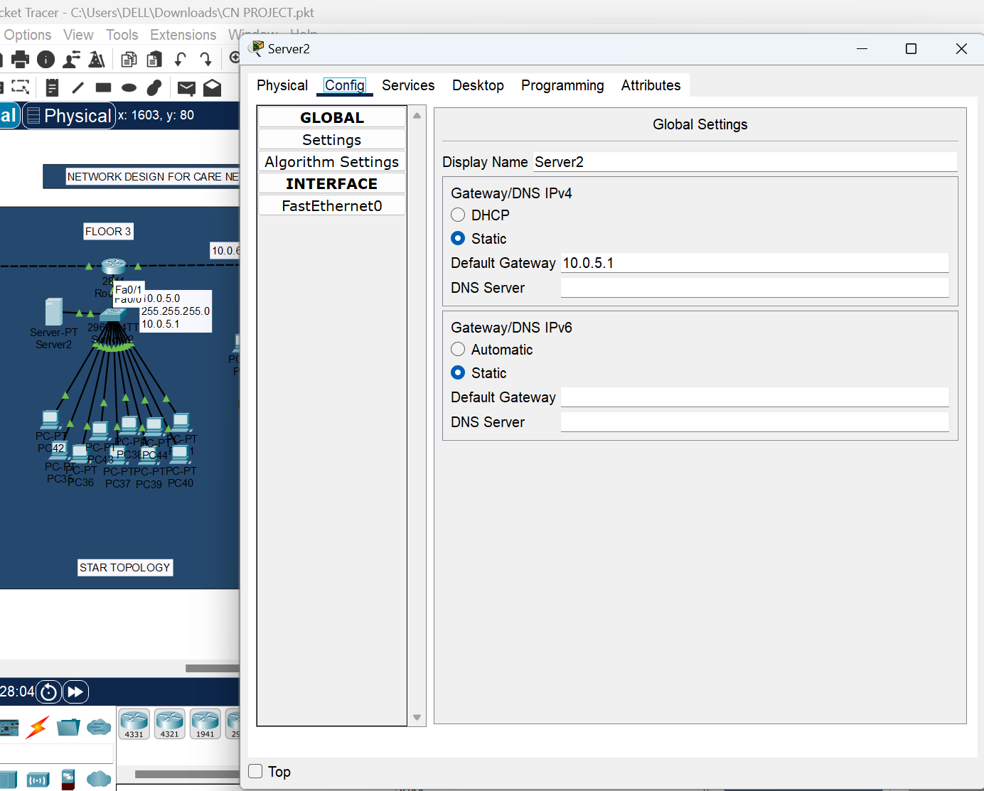

1. **We use Class B private IPv4 addresses for the next two floors**

-The **Class B private IP address range** is **172.16.0.0 to 172.31.255.255**. This range is suitable for medium-sized networks.

1. 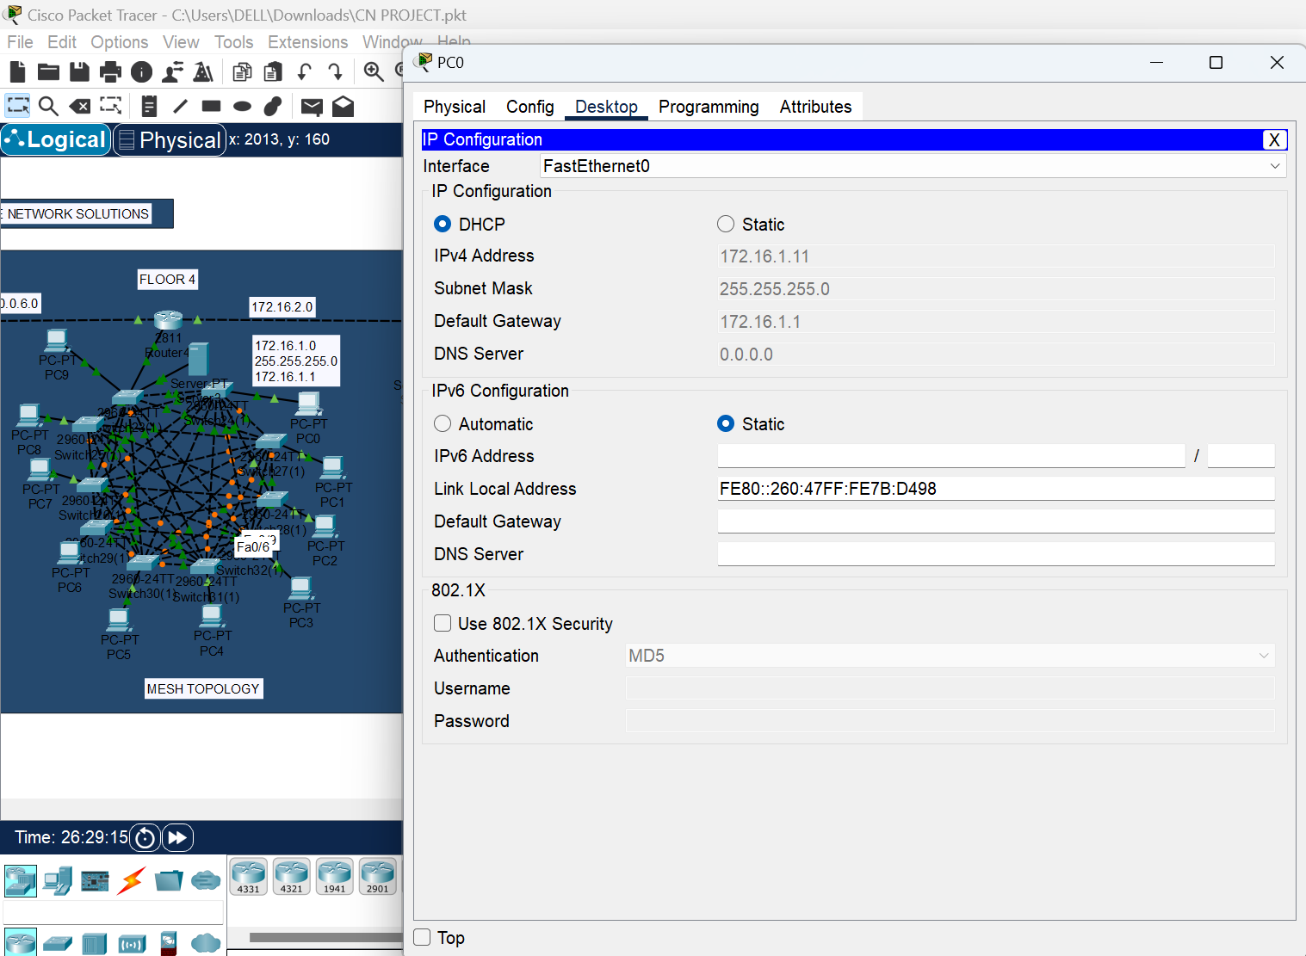**Fourth Floor – Mesh Topology**

**Fourth Floor End – Device Configuration**

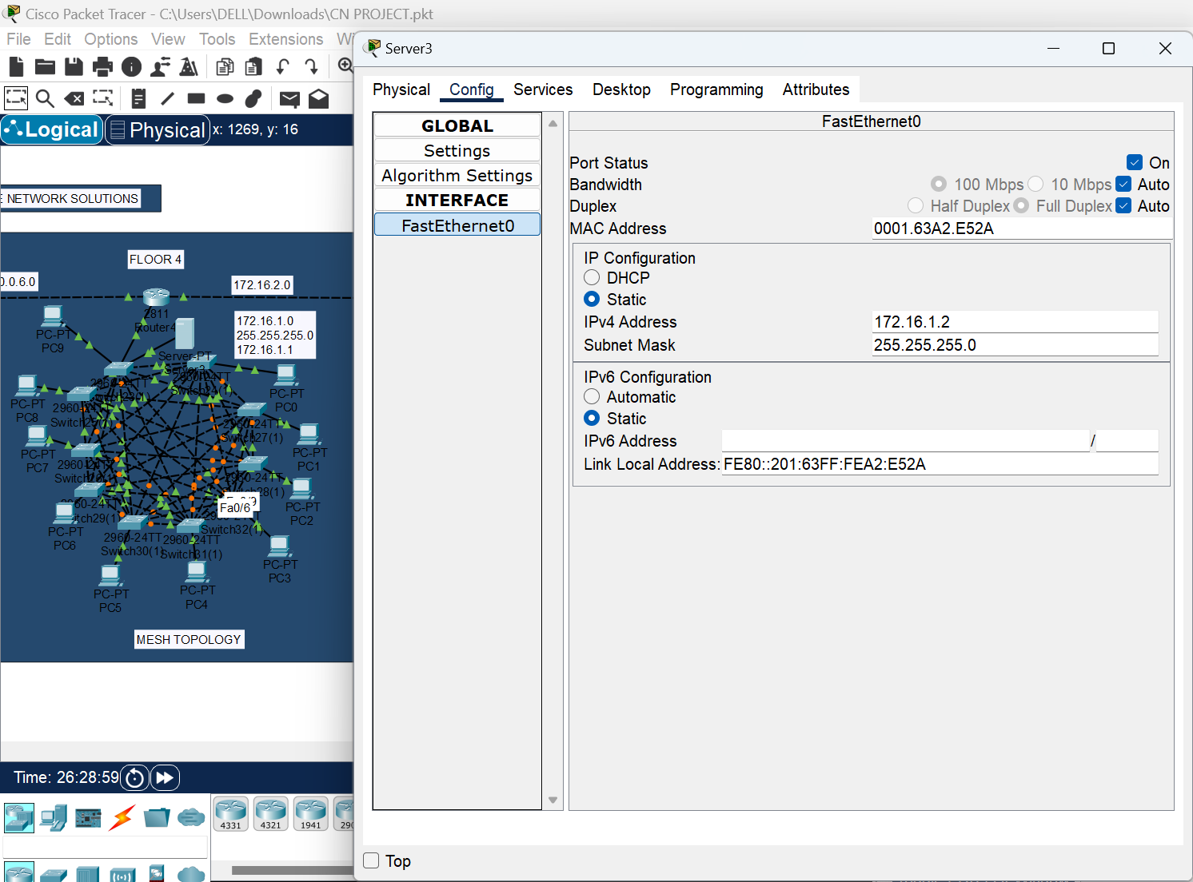

1. **Fifth Floor – Mesh Topology**

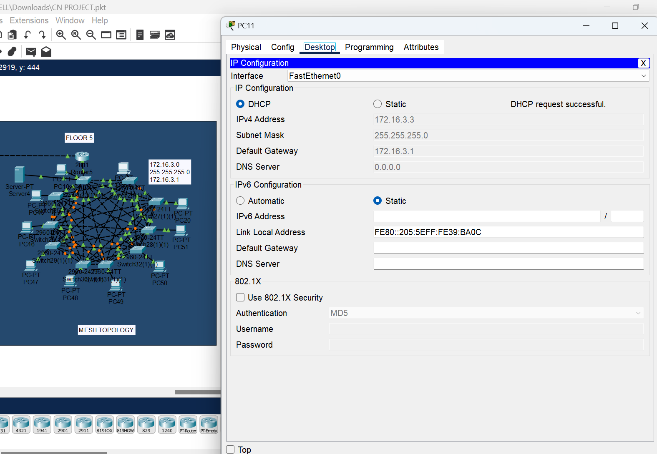

**Fifth Floor End – Device Configuration**

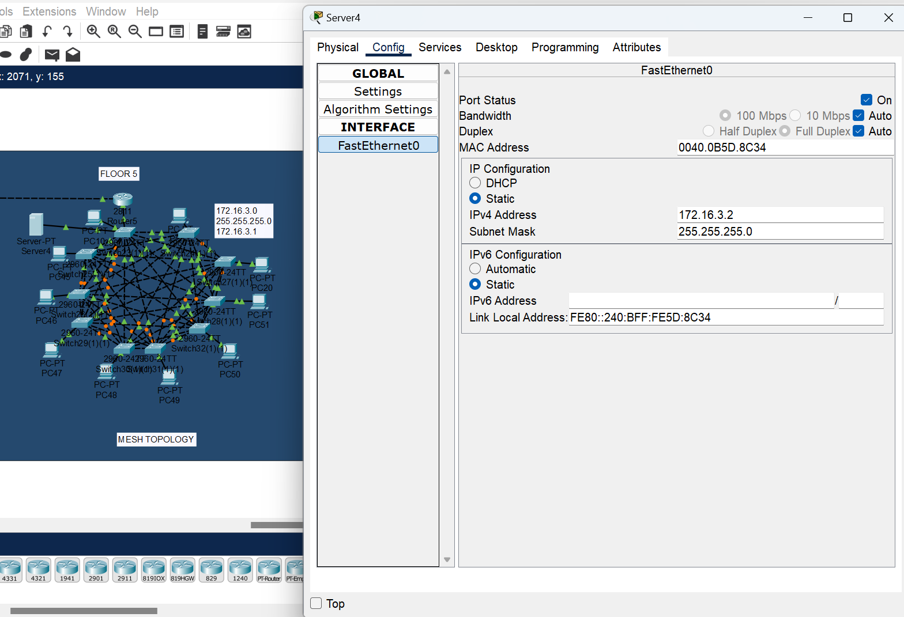

1. **STATIC ROUTING:** Static routing is a manual routing technique where the network administrator defines fixed routes for data packets. These routes do not change unless manually updated.

1. **1st Router - First Floor**

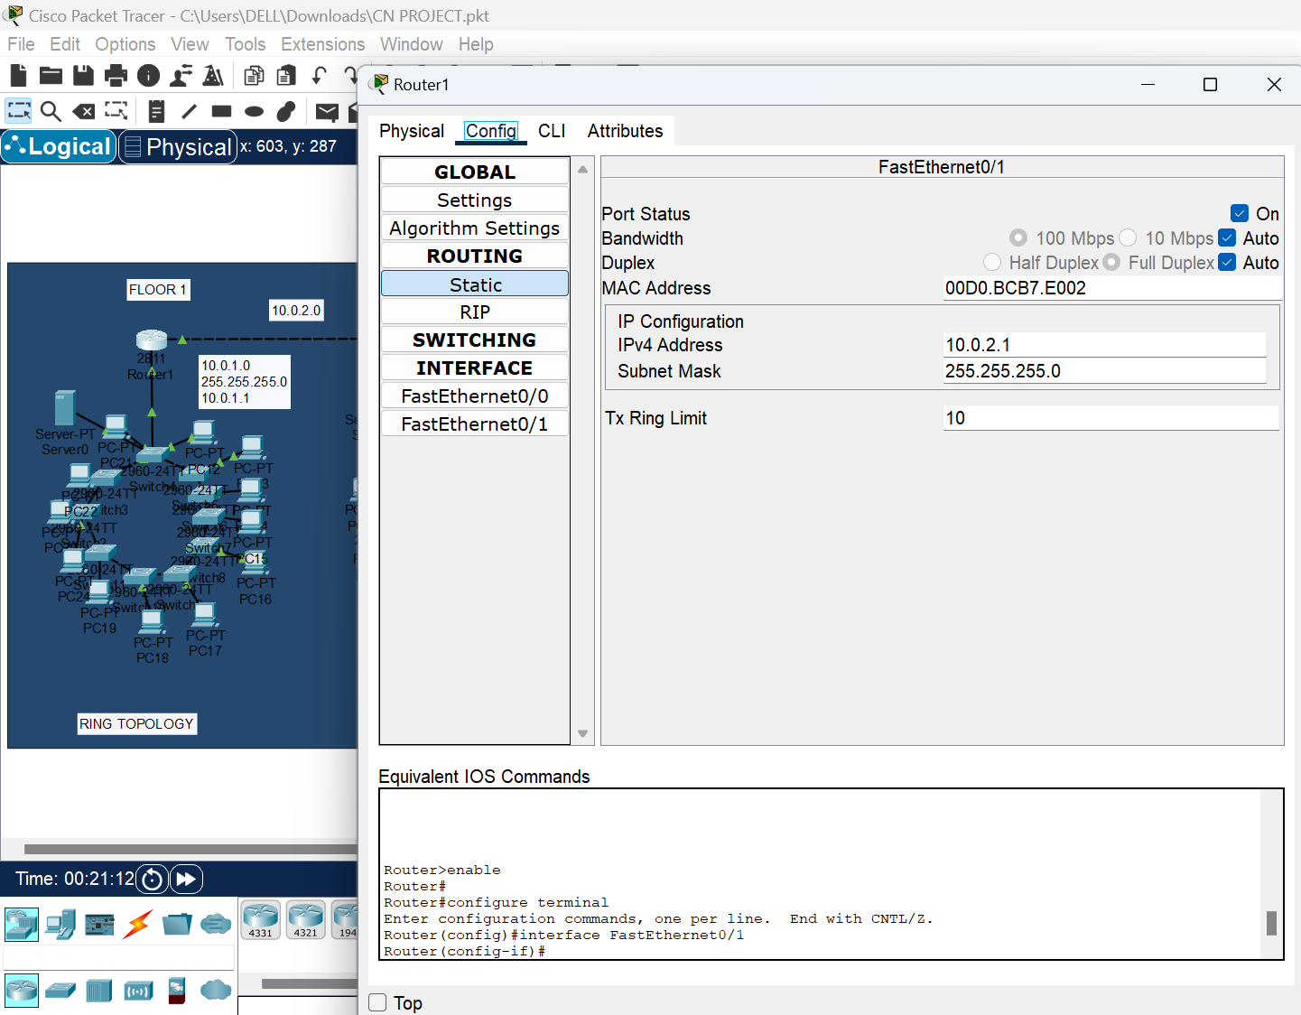

1. **2nd Router – Second Floor**

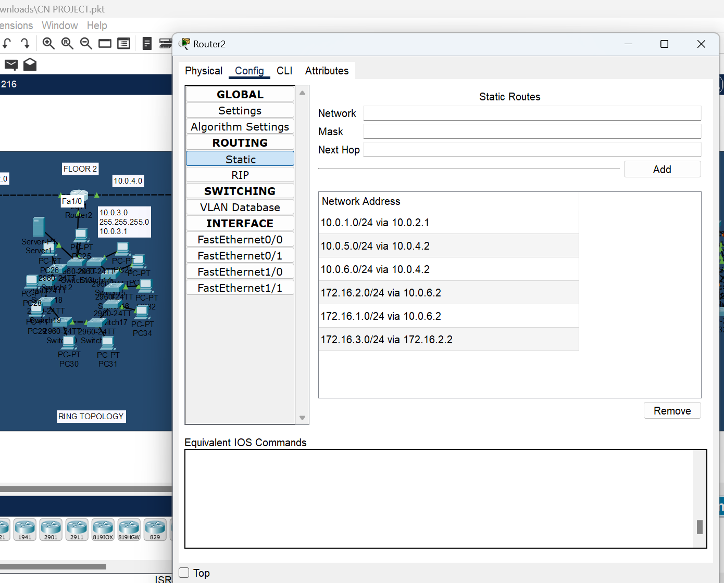

1. **3rd router – Third Floor**

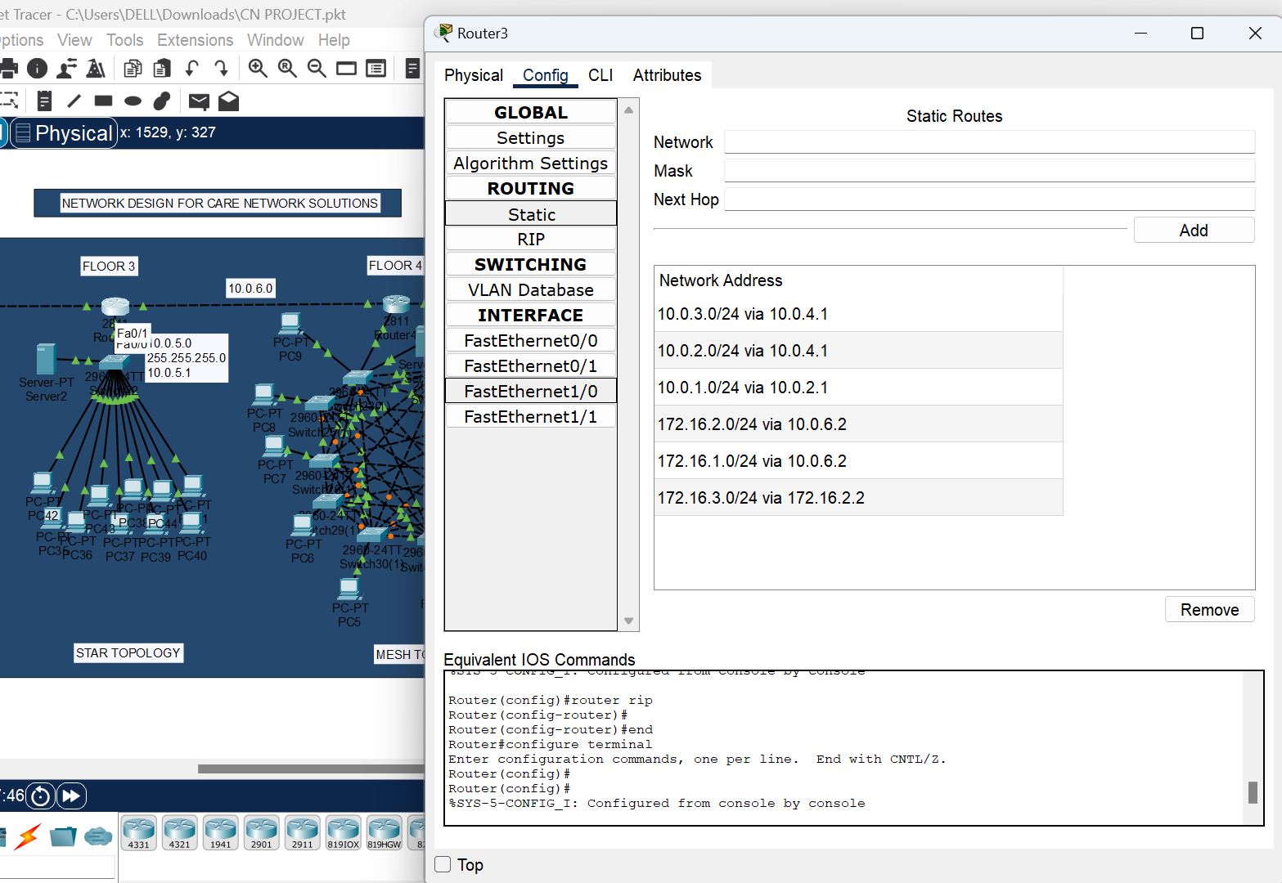

1. **4th router – Fourth Floor**

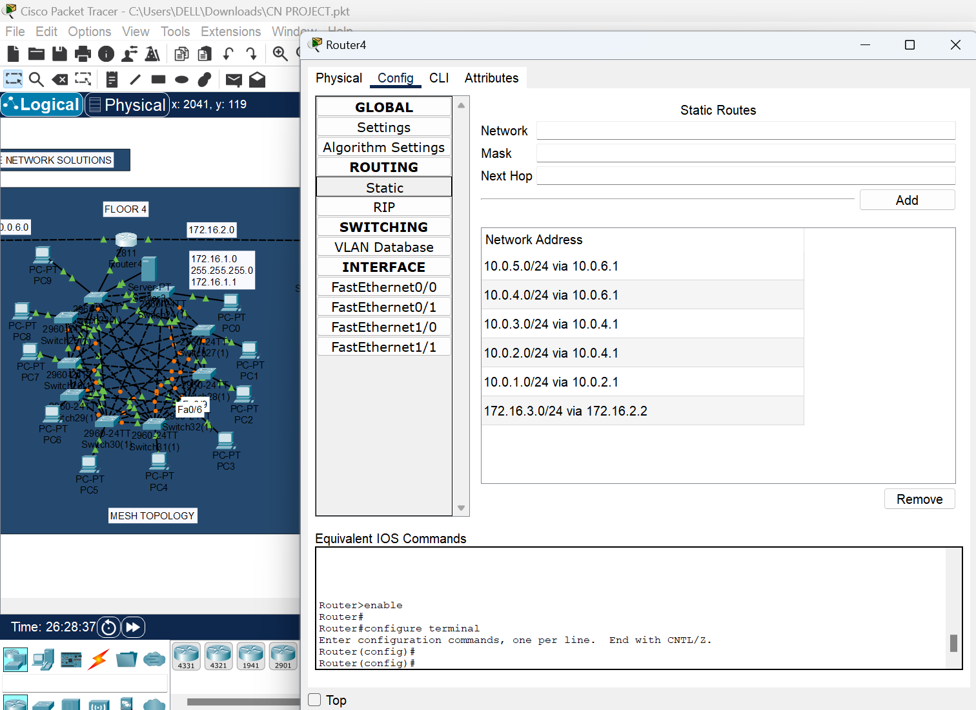

1. **5th router – Fifth Floor**

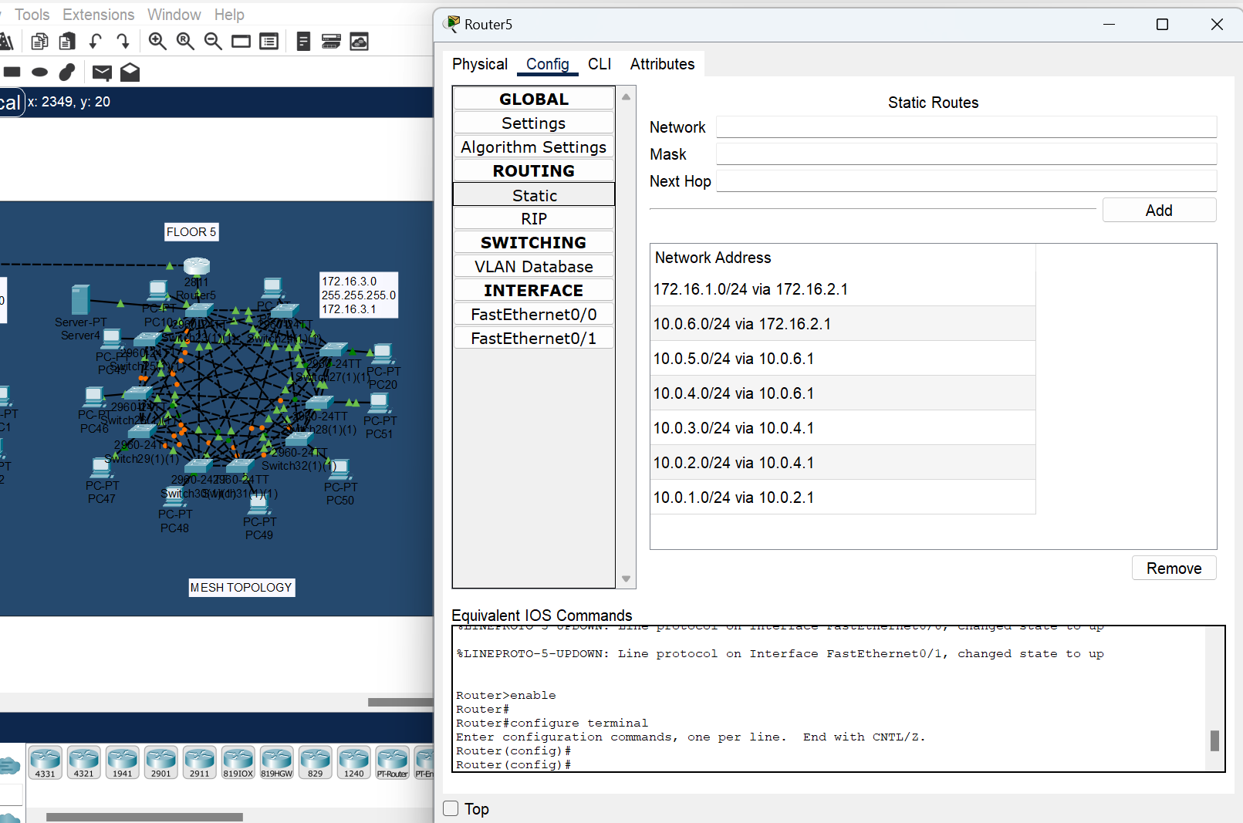

1. **Communication between all Floor :**

* 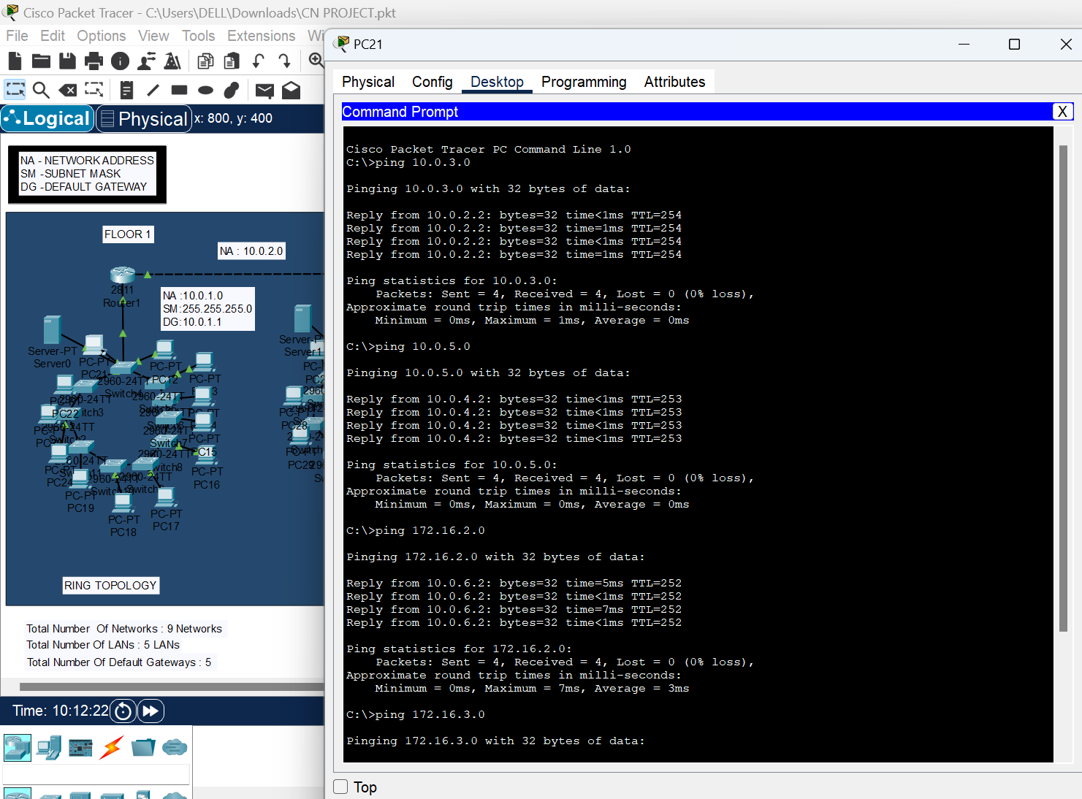**1st Floor PC to all other Floors:**

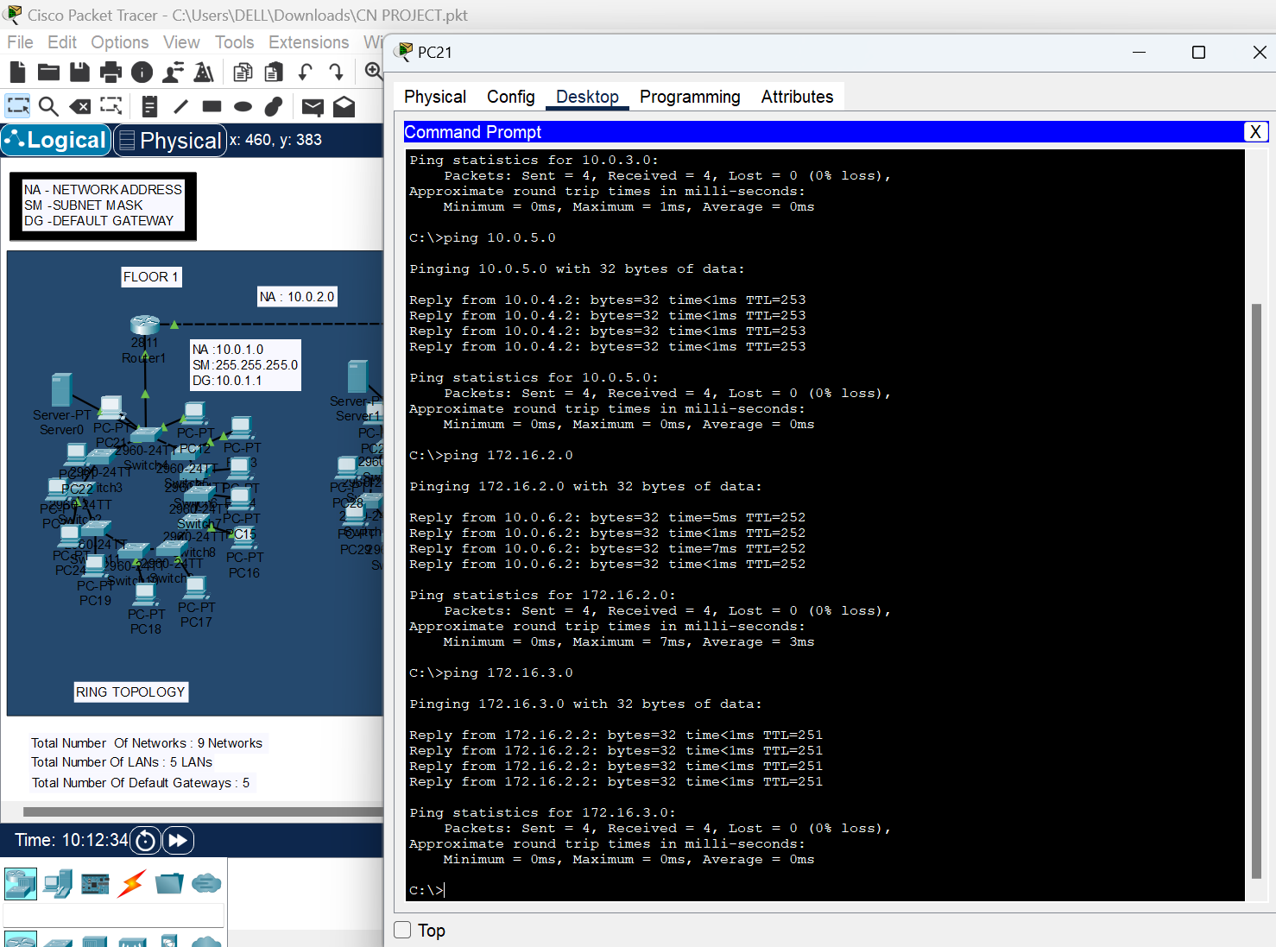

* **5th floor PC to all Floor PC’s** :

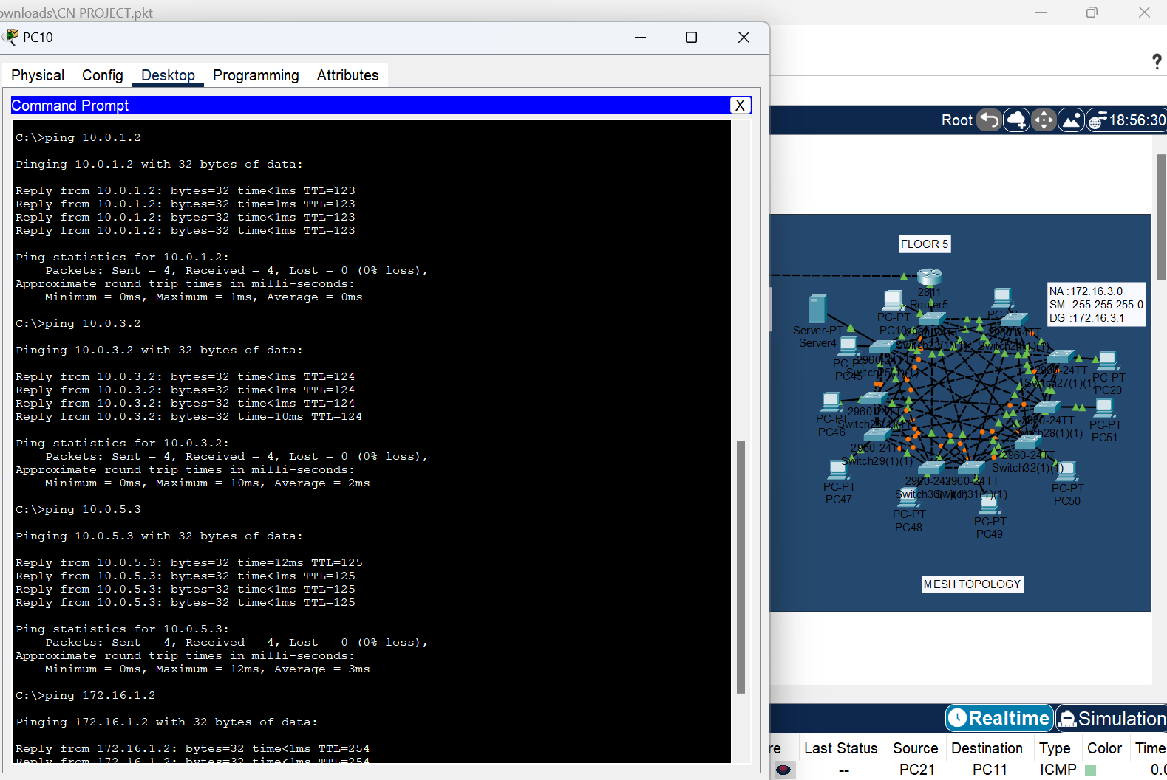

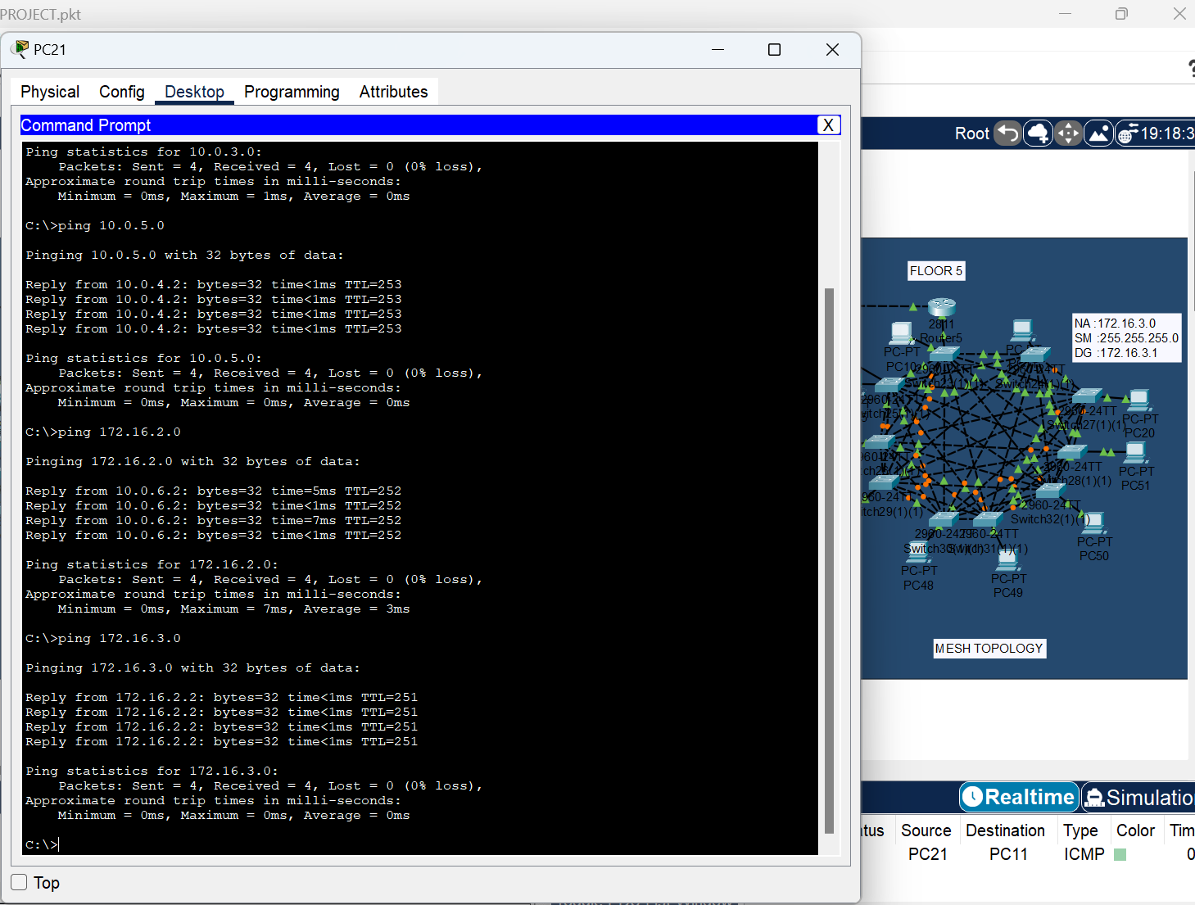

1. **Innovation Done by me:**

**Using Servers in the Network Design**

In my **network design for Care Network Solutions**, servers are used on each floor.

1. **Centralized Resource Management:**
   * Each floor has a dedicated server, ensuring that computing resources, data, and applications are centrally managed, reducing redundancy and improving efficiency.
2. **Efficient Data Handling & Storage:**
   * Servers store essential files, databases, and logs, providing a **reliable and structured** way to manage data access and sharing among users on each floor.
3. **Network Services & Authentication:**
   * The servers likely provide **DHCP, DNS, and authentication services (e.g., Active Directory, LDAP)** to streamline user login, security policies, and device management.
4. **Inter-Floor Communication & Coordination:**
   * Since each floor has a **separate topology (ring, star, mesh)**, inter-floor communication needs reliable servers to handle routing, security policies, and shared access to resources.
5. **Load Distribution & Fault Tolerance:**
   * Instead of one central server for the entire 5-floor network, **dedicated floor-wise servers reduce bottlenecks**, distribute workloads, and improve redundancy in case one server fails.
6. **Security & Access Control:**
   * Servers can enforce **firewalls, VPNs, encryption, and access control policies**, restricting unauthorized access and ensuring secure communication.
7. **Application Hosting & Software Services:**
   * They may host **email, file-sharing platforms, or business applications** needed for seamless collaboration and workflow within the organization.

**Conclusion:**

The **floor-wise server placement** is a well-structured approach to **enhance reliability, security, and efficiency** in the network. It ensures **better data handling, workload distribution, and smooth inter-floor operations**, which is essential for an enterprise-scale network.

1. **GITHUB LINK -** [**https://github.com/sanaperweenss/CSE307/tree/main**](https://github.com/sanaperweenss/CSE307/tree/main)